VERENA pilot plant
VERENA is the acronym for the pilot plant for the gasification of organic matter under the conditions of supercritical water. The maximum throughput of the plant is 100 kg/h. The maximum pressure is 300 bar, the maximum temperature is 700 °C. Different process layouts are easily realized by switching valves.
Pos. 1: Scope of delivery
Complete hardware of the KIT´s pilot-plant (VERENA) for SCWG consisting of:
- Feed system (with 3 tanks, 4 HP (high pressure) pumps, macerator and colloid mill, low-pressure pumps)
- HP-Tubing
- Tube-in-tube heat exchanger (patented) as described in publication.
- First pre-heater operated electrically. Indirect heating with a nitrogen-closed loop with a high-temperature fan and cyclone for salt separation.
- Main heater operated with flue gas (from the combustion of propane, including combustion chamber, burner, high-temperature fan), forming an open loop.
- Reactor with a volume of 30 L.
- Second salt separation system and patented pressure release system.
- Three water driven coolers.
- Pressure regulation system including phase separation. It comprises an HP autoclave, a phase detection system, HP filters, and valves.
- CO₂ scrubber consisting of a high-pressure loop including an autoclave, high-pressure pump, tanks and high-pressure washing column.
- System for filling HP-gas bottles with pressurized product gas.
- Flare for the combustion of the residual product gas.
- Process measuring and control technology devices (MSR) from Siemens (SIMATIC) with two PCs and corresponding software (Step 7, WIN CC) with license.
- Online analytics for the main components of the product gas (process gas analyzer) connected with the MSR and the PC system.
- All equipment necessary for the operation of the plant is included, except for the wastewater collection system, after pressure release to ambient pressure, which is partly installed under the ground. Also, the housing and the fundament are not included.
- All drawings and documents necessary for the yearly permission of the operation from the corresponding authority (e.g., TÜV) in the German language.
The plant needs minor repairs and a new inspection from the German TÜV (or other authority) to prepare for operation.
The plant has been operated for more than 2000 h over the last several years, and it is assumed that several components show corrosion, salt deposits, and rests of organic matter. After disassembling, cleaning the individual components is advisable.

Additional information.
The building (not to sell) in which VERENA facility is currently installed has the following dimensions:
23x18x8 (LxWxH in m).
The required area can be reduced to 12x18x8 m just by changing the arrangement of the components and with only minor changes in few high-pressure tubes.
The plant should be disassembled and removed from the area of KIT – at buyer’s costs and responsibility- at the latest three months after signing the contract Pos.1, or 9 months if Pos. 2 will also be booked. KIT can provide the contacts of specialized companies that can perform the disassembling and re-assembling at the buyer’s location.
The documentation of the hardware of the plant will be handed out after purchase.

For further technical information, please contact:
Dr. Nikolaos Boukis, Nikolaos.boukis@kit.edu
Visiting of the plant is possible.

Technical description of the VERENA plant
(from Nikolaos Boukis and I. Katharina Stoll, Gasification of Biomass in SupercriticalWater, Challenges for the Process Design—Lessons Learned from the Operation Experience of the First Dedicated Pilot Plant. Processes 2021, 9,455, 1-17)

The KIT pilot plant VERENA has a maximum throughput of 100 kg/h (max. 20 wt.% dry biomass), usual throughput is 50 kg/h. The maximum operating pressure and temperature are 350 bar and 700 °C, respectively. Standard reaction conditions are typically 660 °C and 280 bar. The plant consists of three main sections: the feed system, the reaction system and the separation system. A simplified process scheme is depicted in Fig. 1.
The feed system consists of several tanks, a macerator, a colloid mill and several high-pressure pumps. Liquid organic wastes like crude glycerol can be pumped directly to the reaction system. Biomass or waste materials containing larger particles have to be pre-treated (see Section 2.2). The water content of the feed is adjusted to gain a homogeneous feed suitable for pumping. The obtained slurry is dosed into the reaction system by a mass flow controlled high-pressure metering pump.
The feed slurry then enters the first component of the reaction system, a double-pipe heat exchanger with an exchange surface of 1.8 m² and is heated in counter-current flow by the hot effluent of the reactor (T ≈ 550 °C). During operation with concentrated biomass slurries, some fouling occurs and the heat transfer coefficient (h) is reduced.

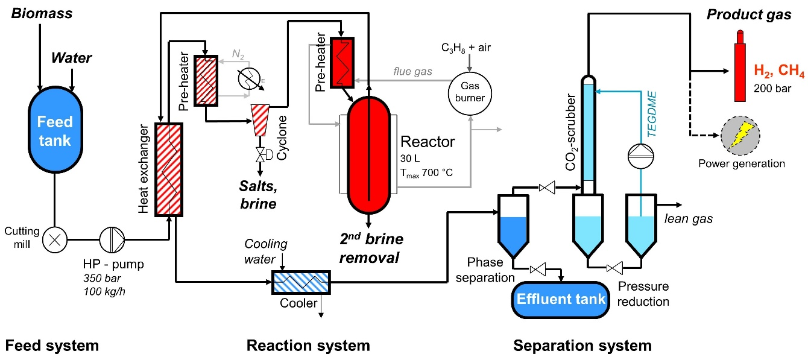

Figure 1: Simplified scheme of the VERENA pilot plant (One-stream process configuration).
In another process layout, an second heat exchanger/preheater (less than 20 kW, indirect electrical heating) is installed after the first heat exchanger and adjusts the temperature of the fluid from about 400 °C up to 480 °C. This enables an efficient separation of inorganic salts, as their solubility is drastically reduced at supercritical conditions. Separation therefore occurs by gravity and flow inversion (sharp change from downflow to upflow) or by a high temperature, high pressure cyclone. The cyclone has a narrow inner diameter (i.d.) of 35 mm. This device separates salts, which have formed solids suspended in the supercritical water or dense brines, before precipitation on the tubing wall. The linear velocity of the feed stream at a temperature of 400 °C is in the range of 2 m/s and reaches approximately 4 m/s at 450 °C. This is due to the lower density of the supercritical water at higher temperatures. The resulting man-made gravity is 10 to 30 times higher than usual and enables a fast separation. The solids from the cyclone are removed in a discontinuous mode by very short pressure releases from 280 bar to ambient pressure with a high throughput. The mean output of the separated brine stream is about 1 kg/h. The salt separation at this position is not obligatory. In case of feed materials with a low fraction of inorganic components or in process configurations with a different preheater design, it is possible to omit the salt separation at this stage of the process.
The next component of the reaction system is the main preheater, which is externally heated by the flue gas of a burner with 60 kW(max) power. It is operated at an external wall temperature (high-pressure tube, 9/16” outer diameter (o.d.), 60 m length) of 700 °C.
The preheated feed slurry is then led into the down-flow reactor, a slim vessel with a volume of approx. 30 L (10 cm i.d.) to guarantee the required residence time. There is not enough surface available to heat the reactor externally, but the hot flue gas exiting the preheater is recirculated to prevent temperature losses. A feature, first time realized in the VERENA pilot plant, is the separation of brines and solids from the main product stream in the lower part of the reactor. The main product is directed to the upwards via a thin tube and subsequently led to the heat exchanger. Brines or solids, if not already removed in the cyclone, accumulate in the lower part of the reactor and are drained in a manner similar to the cyclone (see Fig. 1). This is beneficial in order to avoid clogging and to reduce fouling of the heat exchanger. These process layouts were invented at the time of construction of the VERENA pilot plant (see Section 6).
Another layout provides a moderate heating of the biomass below the critical temperature (374 °C), using only a small part of the heat exchanger. Thus, precipitation of inorganic salts at this stage is avoided. The largest part of the heat exchanger and the preheater is employed for a second stream of pure water, which reaches high temperatures. Both streams are mixed at the top of the reactor (see Fig. 2), which enables heating of the biomass up to reaction temperature. The salts will be transported downwards by gravitation and accumulate at the lowest part of the reactor, where they will be drained by the brine removal system. Due to the dilution of the feed stream inside the reactor, this process layout is suitable for concentrated feeds. A cyclone is not necessary.

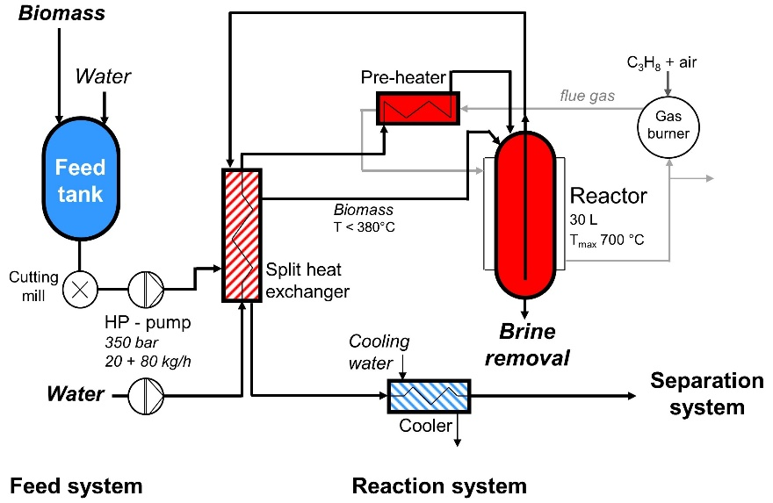

Figure 2: Two-stream process configuration: simplified scheme of the feed and reaction system.

In the third Section of the pilot plant, the product gas is separated and stored in high-pressure gas bottles. At supercritical conditions, the gaseous reaction products are soluble in water and thus leave the reactor as part of a homogeneous phase, passing the heat exchanger and a cooler. By cooling down the reaction mixture, gases separate from the water phase. Via a level control, the liquid phase is passed on to a separator operated at ambient pressure to remove lean gas. Finally, the effluent is collected in a tank, analyzed and discharged to a treatment plant.
The pressure of the gas phase can be reduced in one or two steps, respectively. One phase separator is additionally equipped with an integrated scrubber to remove CO₂, gaining a mixture of only combustible gases. The scrubbing column for CO₂ separation is filled with Pall rings. By dissolving CO₂ in cold water or TEGDME (tetraethylene glycol dimethyl ether), its content in the product gas is reduced. The remaining product gas can then be filled into high-pressure gas bottles. Excess gas is expanded to a pressure required for further treatment, or just combusted in a flare.

